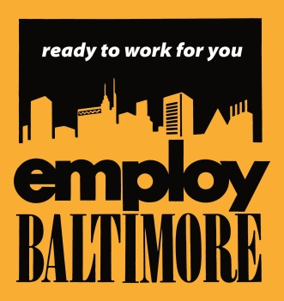
www.oedworks.com

Eastside One-Stop Career Center    3001 E. Madison St.  Baltimore, MD 21205  410-396-9030  Northwest One-Stop Career Center  2401 Liberty Heights Ave.  Mondawmin Mall  Baltimore, MD 21215  410-396-7873  Westside Youth Opportunity (YO Baltimore)  1510 W. Lafayette St.  (Gilmor St. entrance)  Baltimore, MD 21217  410-545-6953  Eastside Youth Opportunity (YO Baltimore) HEBCAC  1212 N. Wolfe St.  Baltimore, MD 21205  410-732-2661  Workforce Reception Center  (By referral only)  100 W. 23rd Street  Baltimore, Maryland 21218  Phone (410) 396-6580  Visit one of our Satellite Employment Centers!  Bon Secours Community Works  26 N. Fulton Ave.  Baltimore, MD 21223  410-362-3629  GEDCO  5513 York Rd.  Baltimore, MD 21212  410-532-7117  My Brother’s Keeper  4207 Frederick Avenue  Baltimore, MD 21229  410-644-3194  Employment Connection Center  1410 Bush Street  Baltimore, MD 21230  410-396-1052 |  | All applicants must register with the Maryland Workforce Exchange. Please visit Maryland Workforce Exchange (MWE) at: https://mwejobs.maryland.gov. If you do not have access to a computer or email, stop by a One Stop Career Center as listed on the left.    A local tutoring and staffing company is looking for  What is an IEP Aide? Individual Education Program Aide is an individual assigned to help and support a student with special needs. The responsibilities can be but not limited to classroom assignment assistance, behavior management, ambulation, and/or toileting assistance (for children with physical disabilities).  Shifts are: Monday -Friday (Hours depend on individual schools)  Hourly Wage: $12.00-$12.50  HS Diploma/GED Required, Child Care Experience a plus  Schools are located in Baltimore City  **A Background Check is Required**  Thursday, September 7, 2017 at 10am  Eastside Career Center  3001 E. Madison Street Baltimore, MD  **Note: Please bring a copy of Diploma or GED  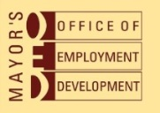  "Apply Now” is a service of the Mayor's Office of Employment Development, the Baltimore Workforce Development Board and multiple workforce partners."  

